**1. ReactJS-HOL**

Create a new React Application with the name “myfirstreact”, Run the application to print “**welcome to the first session of React**” as heading of that page.

Answer:

**Command Prompt:**

npm install -g create-react-app

npx create-react-app myfirstreact

cd myfirstreact

code .

**VS CODE:**

[**App.js**](http://app.js)

function App() {

return (

<h1>Welcome to the first session of React</h1>

);

}

export default App;

**Command Prompt**

npm start

**Output:**

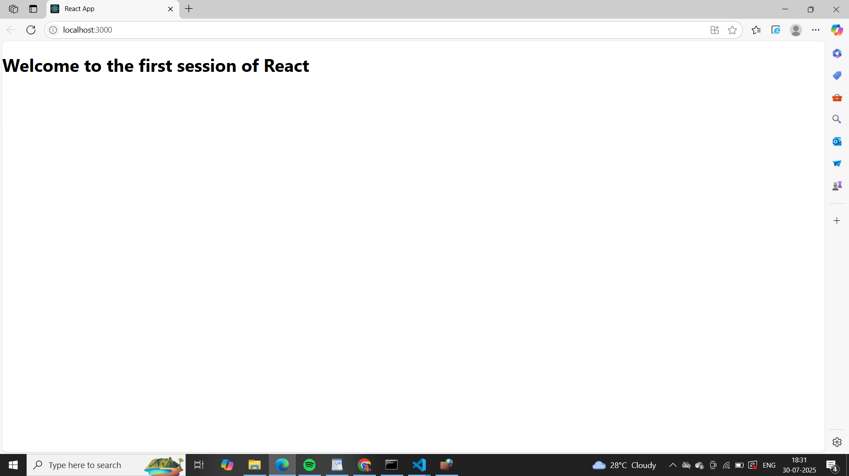

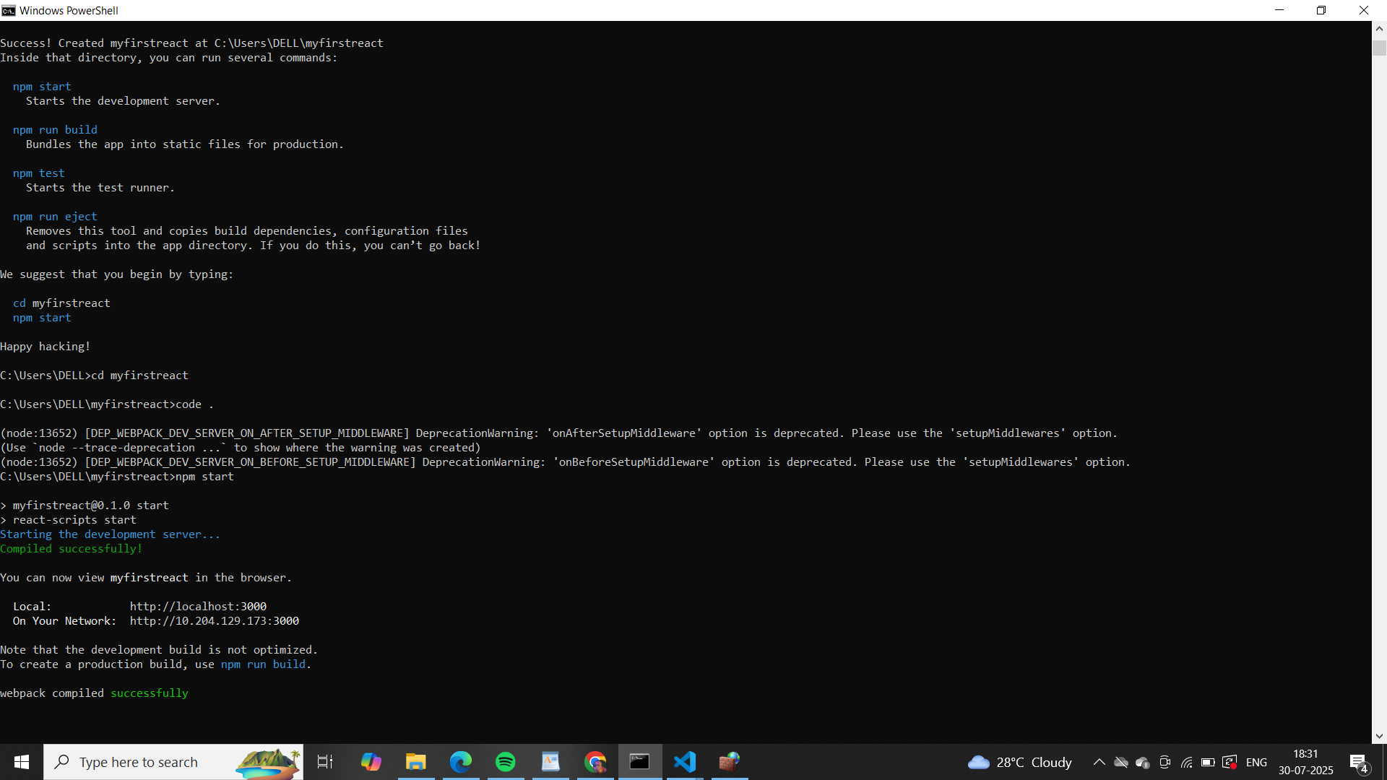

**2. ReactJS-HOL**

Create a react app for Student Management Portal named StudentApp and create a component named Home which will display the Message “Welcome to the Home page of Student Management Portal”. Create another component named About and display the Message “Welcome to the About page of the Student Management Portal”. Create a third component named Contact and display the Message “Welcome to the Contact page of the Student Management Portal”. Call all the three components.

Answer:

**Command Prompt:**

npx create-react-app studentapp

cd StudentApp

code .

**Components/**[**Home.js**](http://home.js)

import React, { Component } from 'react';

class Home extends Component {

constructor(props) {

super(props);

// you could initialize state here if needed

// this.state = {};

}

render() {

return (

<div>

<h3>Welcome to the Home Page of Student Management Portal</h3>

</div>

);

}

}

export default Home;

**Components/**[**About.js**](http://about.js)

function About() {

return (

<div>

<h3>Welcome to the About Page of Student Management Portal</h3>

</div>

);

}

export default About;

**Components/Contact.js**

function Contact() {

return (

<div>

<h3>Welcome to the Contact Page of Student Management Portal</h3>

</div>

);

}

export default Contact;

[**App.js**](http://app.js)

import './App.css';

import Home from './Components/Home';

import About from './Components/About';

import Contact from './Components/Contact';

function App() {

return (

<div className="container">

<Home />

<About />

<Contact />

</div>

);

}

export default App;

**Output:**

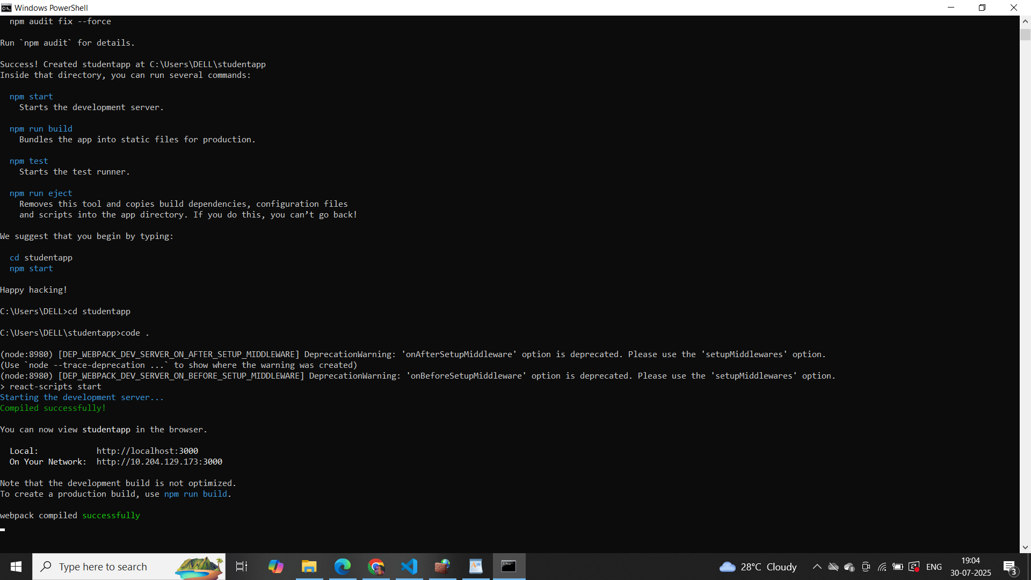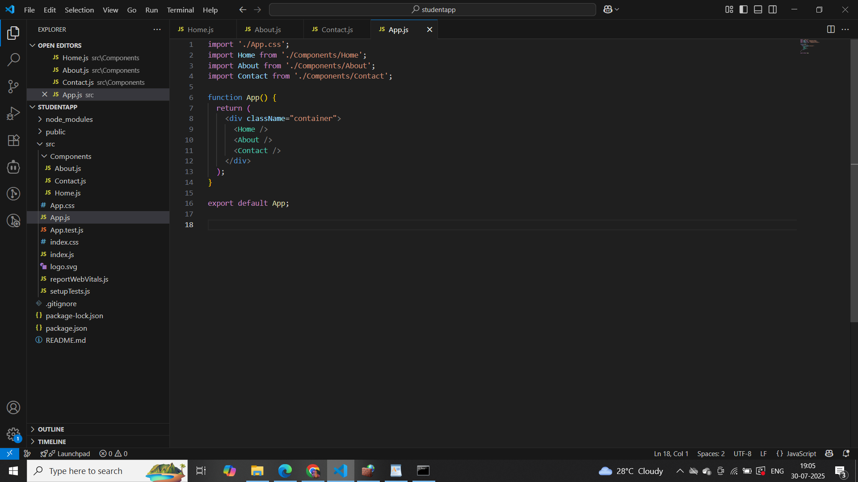

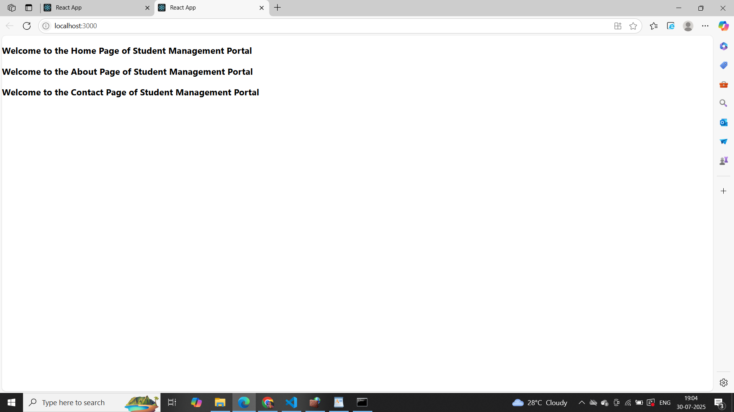

**3. ReactJS-HOL**

Estimated time to complete this lab: 30 minutes. Create a react app for Student Management Portal named scorecalculatorapp and create a function component named “CalculateScore” which will accept Name, School, Total and goal in order to calculate the average score of a student and display the same.

Answer:

**Command Prompt**

npx create-react-app scorecalculatorapp

cd scorecalculatorapp

code .

**VS CODE**

[**CalculateScore.js**](http://calculatescore.js)

import React from 'react';

import '../Stylesheets/mystyle.css';

const percentToDecimal = (decimal) => {

return (decimal * 100).toFixed(2) + '%';

};

const calcScore = (total, goal) => {

return percentToDecimal(total / goal);

};

export const CalculateScore = ({ name, school, total, goal }) => (

<div className="formatstyle">

<h1><font color="Brown">Student Details:</font></h1>

<div className="Name">

<b><span>Name: </span></b>

<span>{name}</span>

</div>

<div className="School">

<b><span>School: </span></b>

<span>{school}</span>

</div>

<div className="Total">

<b><span>Total: </span></b>

<span>{total}</span> Marks

</div>

<div className="Score">

<b>Score: </b>

<span>{calcScore(total, goal)}</span>

</div>

</div>

);

**mystyle.css**

.Name {

font-weight: 300;

color: blue;

}

.School {

color: crimson;

}

.Total {

color: darkmagenta;

}

.formatstyle {

text-align: center;

font-size: large;

}

.Score {

color: forestgreen;

}

**src/App.js**

import './App.css';

import { CalculateScore } from './Components/CalculateScore';

function App() {

return (

<div>

<CalculateScore

Name={"Steeve"}

School={"DNV Public School"}

total={284}

goal={3}

/>

</div>

);

}

export default App;

**Output:**

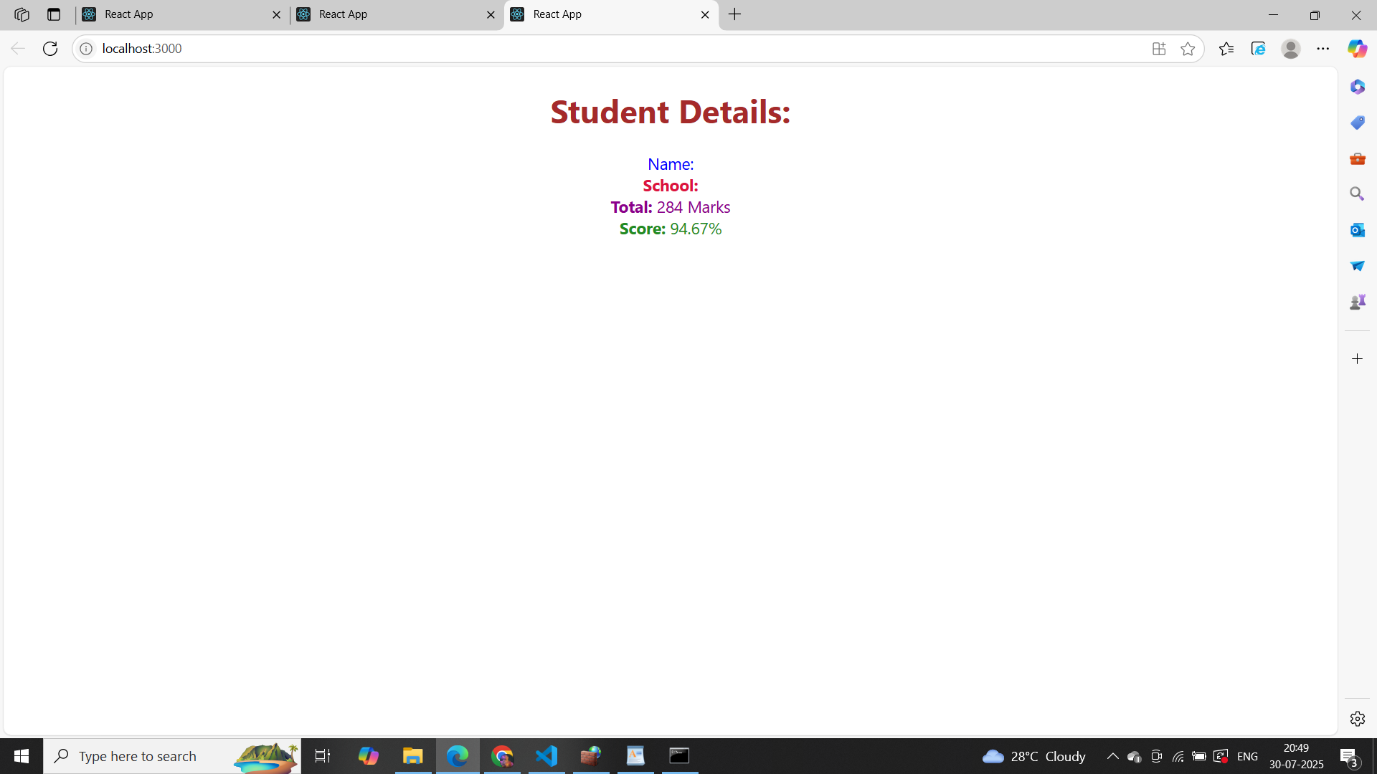

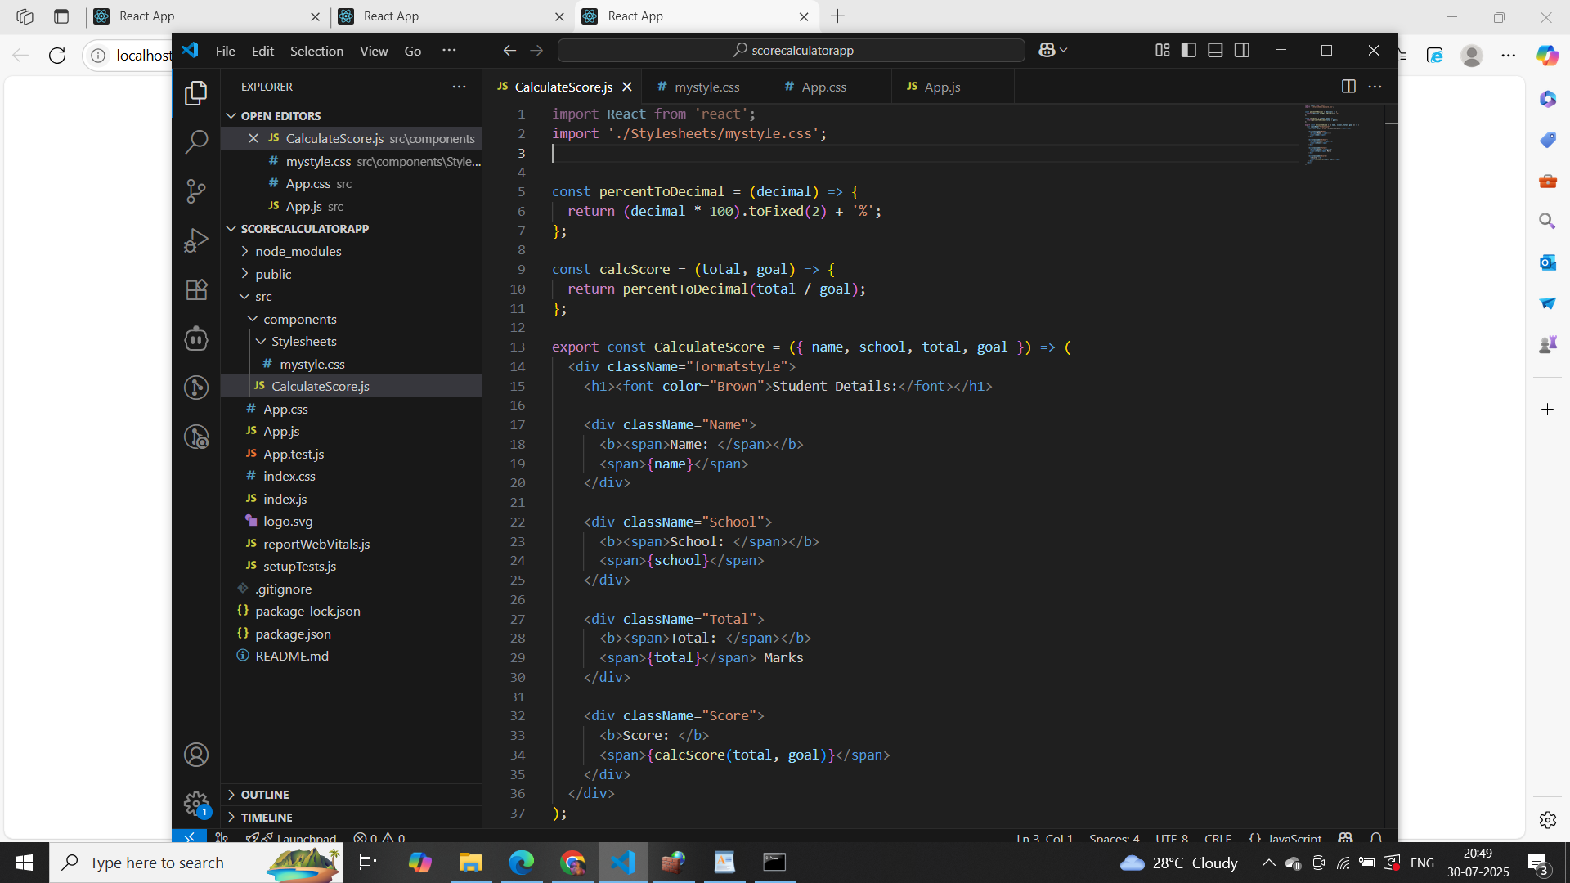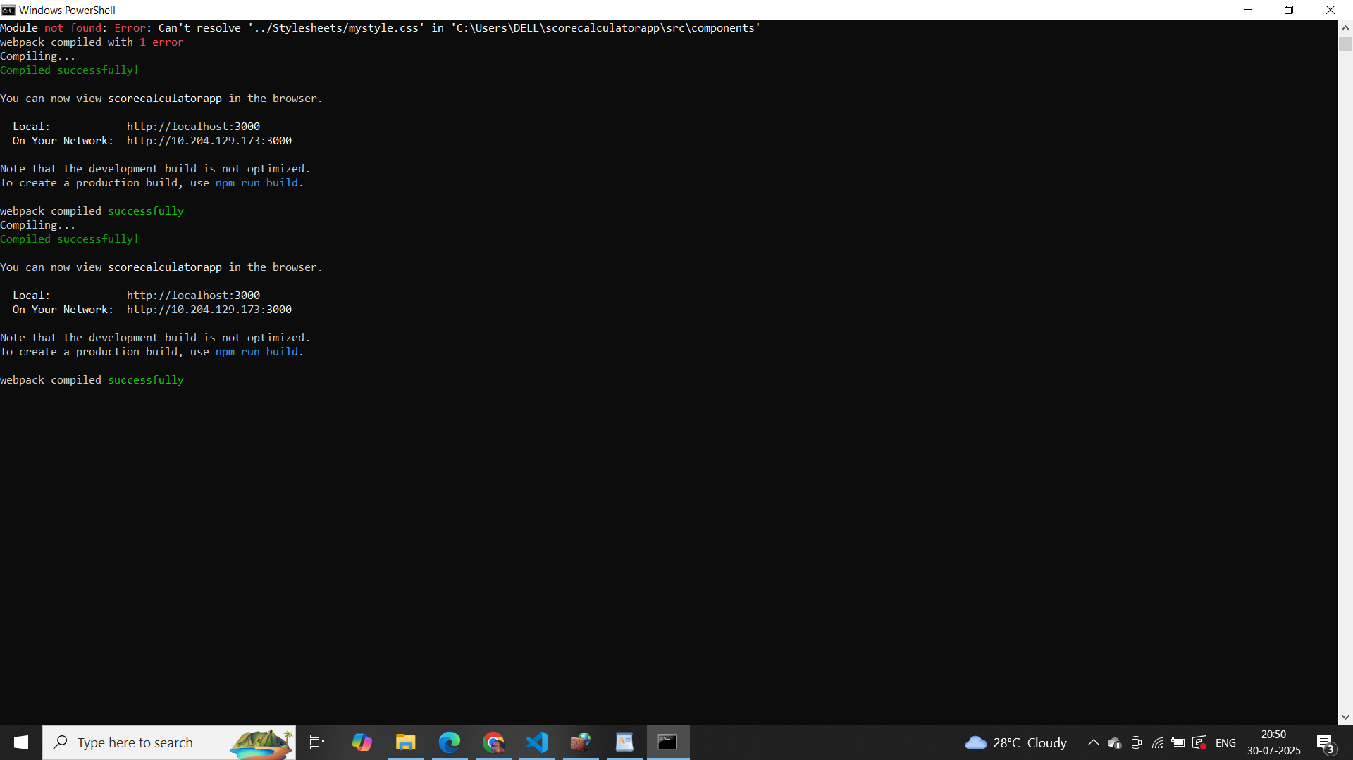

**4. ReactJS-HOL**

Answer:

**Command Prompt**

npx create-react-app blogapp

cd blogapp

code .

[**Post.js**](http://post.js)

// src/Post.js

class Post {

constructor(id, title, body) {

this.id = id;

this.title = title;

this.body = body;

}

}

export default Post;

[**Posts.js**](http://posts.js)

// src/Posts.js

import React from 'react';

import Post from './Post';

class Posts extends React.Component {

constructor(props) {

super(props);

this.state = {

posts: [],

hasError: false,

};

}

loadPosts() {

fetch("https://jsonplaceholder.typicode.com/posts")

.then((response) => response.json())

.then((data) => {

const postList = data.map(post => new Post(post.id, post.title, post.body));

this.setState({ posts: postList });

})

.catch((error) => {

console.error("Error loading posts:", error);

this.setState({ hasError: true });

});

}

componentDidMount() {

this.loadPosts();

}

componentDidCatch(error, info) {

alert("An error occurred: " + error);

this.setState({ hasError: true });

}

render() {

if (this.state.hasError) {

return <h2>Something went wrong.</h2>;

}

return (

<div>

<h1>Posts</h1>

{this.state.posts.map((post) => (

<div key={post.id} style={{ marginBottom: "1rem" }}>

<h3>{post.title}</h3>

<p>{post.body}</p>

</div>

))}

</div>

);

}

}

export default Posts;

[**App.js**](http://app.js)

// src/App.js

import React from 'react';

import './App.css';

import Posts from './Posts';

function App() {

return (

<div className="App">

<Posts />

</div>

);

}

export default App;

**Output:**

